WHAT IS THE EU
EU ^{Def} This is a trading bloc and political alliance of European nations designed to promote closer political,economic and social co-operation among its members

HOW are EU policies and laws made

Policies and EU Laws are made by the following EU Institutions
  - The Council of Ministers 3. The European Commission
  - The European Parliament 4. The court of Auditors
  - The Court of Justice 5. The European Central Bank (ECB)

- The Council of Ministers
- This is also known as the Council of the European Union
- It is the EU most important decision-making body as it is made up of representatives from each member state body
- Its meetings are attended by relevant misisters from each member state
- Each EU country takes turns in presiding over the council for a 6 month period

It’s main functions are
- Set goals and plans for the EU
- Approves the budget for the EU with the EU paraliment
- Approves Laws drafted by the commission and in conjunction with the parliament

- The European Commission
- This institution is responsible for the day-to day management of the EU
- The EU commissioners are senior managers who are appointed by nationa l Governments to run the EU
- Each commissioner is given a different post of reponsibility – transport, competition

The main functions of the European Commission are
- Proposing new laws: they are the only institution to initiate new laws but must consult with interest groups and experts first
- Implementing EU laws and policies: Supervises members states to ensure all EU legislation is implemented.if not they can take a case against them to the court of justice
- Managing the EU budget

- The European Parliment
- They are directly elected by EU citizens to act as a supervisory ‘watch dog’ over all aspects of Eu activities
- It is made up of 700 MEP (Member of Paraliment elected every 5 years)
- Ireland elects 13 MEPs
- The paraliment does not have the power to draft its own legislation

It’s main functions are
- Represents: Represent the views of the EU
- Legislates: They debate and votes on all new ploicies and lasw proposed by the commission.Without their approval proposals can not become law
- Supervises: supervise the running of the EU
- Funding and spending activities
- Interviewing – commissioners jobs

- The Court of Auditors
- They are responsible for ensuring that the EU budget is spent efficently and for the purposr intended
- It checks that all EU revenue is received from members states
- That all expenditure is lawful and well managed
- It can audit any organisation books if they are receiving EU funds

- The Court of Justice
Thye are responsible for ensuring that EU laws are applied the same way in all EU countries. It is made up of one judge from each member state
It tries to iron out any differences between EU and National Law
  - The European Central Bank (ECB)
  - This is based in Franfurt, it is the central bank for all countries and have adopted the Euro as thier comon currency
  - It’s main role is to
  - Keep inflation down
  - Safeguard the value of the Euro
  - Sets interest rates

HOW ARE NEW EU LAWS INTRODUCED
There are 5 stages involved in the introduction of new laws
Stage 1 - Proposal by the commission
Proposal for new laws are prepared by the European Commission
Stage 2 - Consulation with the EU Parliament stakeholders’ groups
The proposal is sent for discussion to the EU Paraliment, national Governments and relevant bodies. At this stage alot of lobbying and campaigning may be undertaken by people, national governemnts, interest groups and MEPs
Stage 3 - Redrafting by the commission
Comments and feedback are received by the commission They may make change to the orginal proposal after the arguments have been made
Stage 4 - Approval by the council
A final version of the proposed law is then sent to he Europena Council for approval or rejection
Stage 5 - Implementation by the commission and national governments
The council of ministers will decide how the law should be implemented
  - This can be done by
  - EU Regulations; legally binding decision that become effective in law immediately
  - EU directive; Set out a goal to be achieved by members states and a deadline for its achievement.
  - EU Decisions; are binding on specifically named counties or companies

WHAT IS THE ROLE OF SPECIAL INTEREST GROUPS IN EU DECISION-MAKING
- EU laws can have major effects on Governments, business and individuals
- Many interest groups try to influence these decisions to suit their members
National Government Industry Bodies
Employer Org (IBEC) Trade Unions
TNC Consumer
Enviromental Org Individuals

Methods of Presuasion
- Lobbying key decision-makers – Ministers, MEPs
- Setting up an office in Brussels and Strasbourg – Large interest groups have permanent staff working close to the commission and Parliament
- Using public Relations - Publicise interest groups views
- Protest

WHAT ARE THE MAIN EU POLICIES
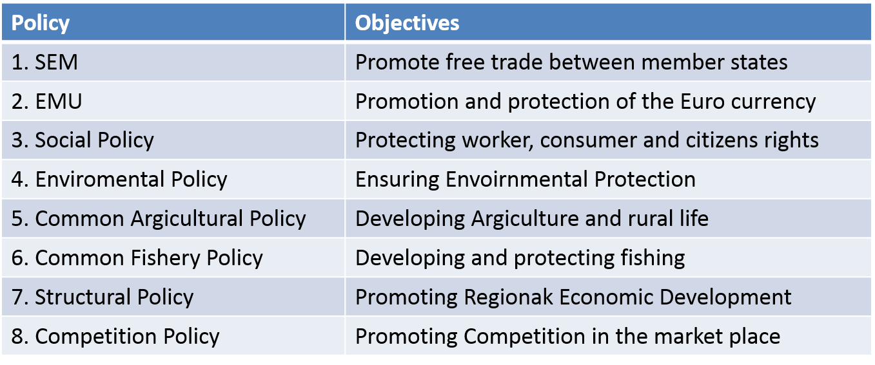

- Single European Policy
This policy is to remove barriers to the free movement of goods, services, people and capital between member states. Business treat the entire EU are one Market

Benefits | Drawback
1. Creation of a huge market | 1. Public Procurement – not allowed to show favouritism
- Free movement of goods | 2. Greater Competition
- Free movement of Capital
- Free movement of Labour
- Tax hormonisation
- Protectionism fro EU Firms
- Foreign Direct Investment

- European Monetary Union
This is the introduction of a common currency for EU members (Euro). The Eurozone is the name given to those EU countries that have replacedtheir national currencies with the Euro . To become a member of the Euro zone certian conditions muct be met – low inflation

Benefits of the EMU | Drawback of the EMU
1. Internationla payments – simpler, cheaper and free from exchange rate risks | 1. Ireland biggest exports are not in the eurozone
2.Increased trade within the Eurozone has been stimulated creating additional jobs | 2. Ireland’s government has to comply with strict EU rules concerning taxationa and spending
3. International Travel – no need to chnage currencies easier to compare prices

- EU Social Policy (Social Chater)
This is to protect the rights of workers and consumers. It is intended to improve and harmonise working conditions and consumer rights throught the EU

Benefits of the EMU | Drawback of the EMU
1. Improved Work Conditions – working hours, hoilday entitlements | 1. Increased costs
2. European Socail fund – Provide funding to train and retain workers and increase adaptability to change

3 Equality of treatment for men and women

4. Consumer rights

4. Common Argicultural Policy
- It is designed to make the EU self sufficient in food and maintain th eincomes of farmers and rural communities
- This is achieved by mondernising farming practices and stabilising the prices of argicultural produce
- This policy aims to improve management of community’s Fishery resources

Benefits of the EMU | Drawback of the EMU
1. A single market for argicultural products with guaranteed prices for farmers produce | 1. Loss of many small farms in favour of large-scale intensive argiculture
2. Farmers have been protected against low-cost food imports from outside the EU | 2. Mechanisation and rationalisation has led to a reduction of direct employment in argiculture
3. Encouraged the development of argi business into major exporting industries | 3. The CAP is the Eus most expensive policy. Costing Eu taxpayers Billions of Euro every Year
4. Food production for the EU is more secure
5. Farmers income has been increase
6. Improve ireland balance of payments

- EU Envoirnmnet Policy
This aims to ensure that economic developments within the Union is ecologically sustainable and is not at the expense of the quality of Europe’s Envoirnment. This is done by

- Making the government and business responsible for thier impact ont he envoirnment (Polluter Pays)
- Ensuring that EU decisions and EU funded projects take into account the environmental Consequences of the actions involved
- Making sure that all large infrastructures are evaluated in terms of envoirnmental impact
- Promote the use of renewable sources of energy

- Structural Funds
Are designed to improve the competitiveness and wealth of the Eus poorer regions and vulnerable industries. Ireland was a major beneficary of these funds. These funds are usually given to the poorer regions of the EU through

- European Regional Development Fund
- European Social Fund
- European cohesion fund

European Regional Development Fund
Aims to reduce differences between the rich and poor regions of the EU
-Imporving Infrastructures - Production methods
-Developing new industries - Reversing economic decline
-Tacking unemployment

Provides grants to economically poorer countries fro infrastructure and envoirnmental improvements projects

- Competition Policy
This sets out rules designed to ensure free and fair trade competition between firms in the SEM. The Europena commission investigates complaints of anti-competitive behaviour by large companies and where trade between EU member states is affected EU competition policy rules cover issues such as
- Competition Policy
- Large Mergers or takeovers
- Monoplies and cartels
- Governments
- Deregulation of monopolies

BENEFITS OF EU MEMBERSHIP TO IRELAND

Business | Employees | Consumers | Economy and the environment
1. Access to a larger wealthy market | 1. Encourages many TNCs to invest in Ireland (Creating Jobs) | 1. They can use the same currency when travelling | 1. Resonible taxation and spending policies (Large deficits are not allowed)
2. EU grants to business (helps them grow) | 2. EU Socail policy enjances employees rights | 2. Increase choice of product (due to the Competition Policy | 2. Benefit from millions of euro in CAP
3. Irish agriculture recevies large amounts of financial support |  | 3. Strong consumer protection legislation | 3. EU policies have forced Irish business and Government to be more environmentally responsible

CHALLENGES IRELAND FACE IN THE FUTURE
- Ireland needs to take greater advantage of the Eurozone (England and The USA are our major exporters)
- Ireland needs to conform with EU rules regarding proper management of the Economy (excessive spending)
- Net contributor to the EU budget – before for every €1 with paid we received €4 in grants. As we get wealthier we will receive less
- 4. Increased competition for investment

ISSUES FACING THE ENTIRE EU
- Protecting the stability of the Euro Currency
- Tax harmonisation – same tax rates in all member countries
- Institutional reform – to ensure greather democracy, accountability and transparency
- Budget reform – reform of the CAP will free up funds for other areas
- Tackling Climate change -

